Design Specification Document

1. Introduction

Project Title: Digital Wellbeing App (App name is tbd)

Project Overview: This app is being made to help its users manage the time they spend on their phones by giving the user the ability to track their screen time and manage any tasks or notes all in one place.

Document Purpose: The purpose of this document is to give team members and stakeholders a single place to see current project targets and goals so the project is staying on track and will be ready by the deadline.

2. Scope and Objectives

Project Goals:

Create an mvp for our app to present during interim presentation which will contain the following feature:

* + Display screen time
  + Reminder section Crud functionality
  + Low fidelity UI
  + Notes with Crud functionality
  + Login/Logout
  + Account creation
* After the mvp is created our goal is to refine and extend the app to contain more features such as:
  + Reminders display notification at the time given by the user.
  + Display screen time data in a easy to understand way for the user
  + Organise screen time data so user is able to see what they are spending the most time on

3. Functional Requirements

* Be able to see the users screen time data in a comprehensible way for the user to understand.
* Have users be able to create and manage reminders including time, alarm, priority.
* Have users be able to create and organise notes
* Have user be able to customise the app to their liking (background, profile photo, app theme)
* Have users be able to create their own accounts linked to the database with crud functionality

...

4. Technical Specifications

Architecture Overview: [Description of technical architecture, platforms, languages, databases] (Will be updated as project progresses) (Raj)

Technical Architecture:

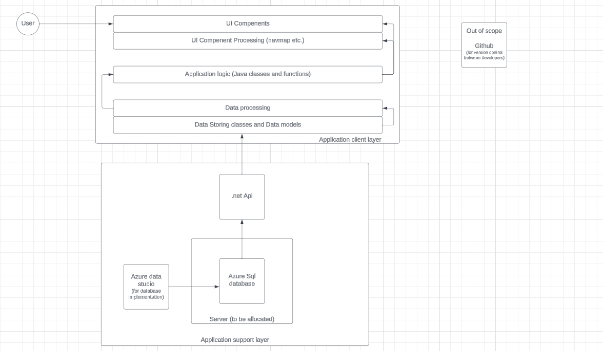

Platforms:

* Android

Programming Languages:

* Java (application development)
* C# (api development)
* SQL (Database)
* Xml (markup language used for ui design)

Development Tools: [List of tools, frameworks, and technologies to be used]

Tools:

* Android studio (app development)
* SQL database (Backend)
* Azure data studio (Backend)
* Figma (UI Design)
* Visual Studio (Api Development)

5. User Interface (UI) and User Experience (UX) Design

Wireframes/Mockups: 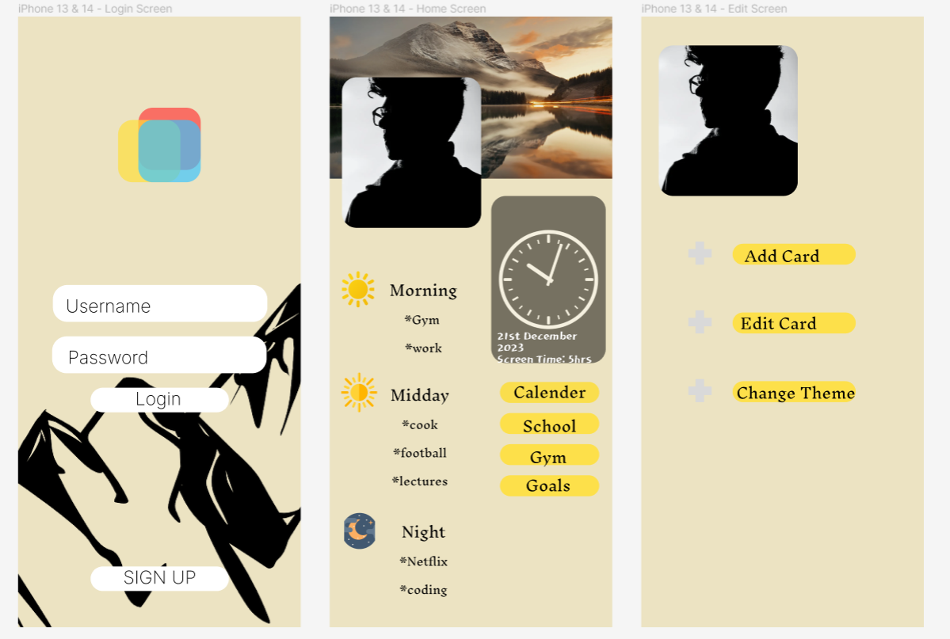

Rough design of UI (subject to change)

6. Security Considerations

User Data Protection:

* We plan to introduce the hashing of all user passwords and sensitive data.
* We plan to include encryption when transferring data between the app and the database.
* When the user is prompted to create a password we plan to include a password strength checker and reject any passwords that don't meet the current standard.
* We plan to clear the app of any unnecessary temporary user data that may be left over after the app finishes processing it.

7. Testing and Quality Assurance

Testing Methodologies:

* Functional Testing: Ensure that each function of the app operates according to specifications. This includes unit testing (testing individual functions), integration testing (testing how different parts work together), and system testing (testing the entire system). Android studio allows for any of our developers to test the application on their own phones provided they are android and have a api level of at least 33 though back-compatibility is being researched
* Usability Testing: Involving actual users (students, faculty, administrators) to evaluate the app's user interface, user experience, and overall usability. We plan to gather feedback on how intuitive the app is and if it meets their needs.
* Performance Testing: Assessing the app's responsiveness, speed, stability, and scalability. Testing how the app behaves under different load conditions to ensure it performs optimally.

8. Acceptance Criteria

Acceptance Criteria:

* View Phone Screen criteria
* Create reminders.
* Write notes.
* Create Calendar Events
* Customise App colours.
* Customise App banners (add own images)